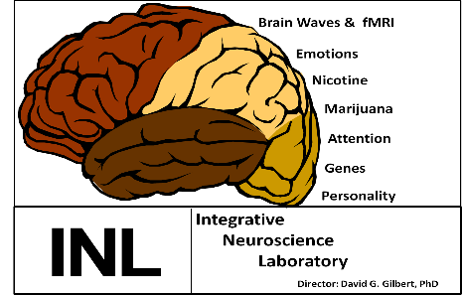
Integrative Neuroscience Laboratory
UGRA Application

Director: David G. Gilbert, PhD dgilbert@siu.edu
Lab Coordinator: Norka Rabinovich norkar@siu.edu
Life Science II: Rooms 278, 287 A &B, 5H-J, 73 I-O
Website: http://www.smokelab.siuc.edu/

Students with a strong academic background and life skills are encouraged to apply.

- Basic Information

Name:
Phone Number:
Email Address:
Year in School:
Major (and Minor):
Expected Graduation Date:
Current overall GPA:
Last semester GPA:
Today’s date:

- Desired credit hours:
We ask for time commitments of 7-10 hours/week for the 1st semester and a commitment for at least two semesters.
Psych 392 2 credits hours=7 hours/week. Psych 392 3 credit hours=10 hours/week.
Are you interested in 2-credit hours (7 hours/week)? ___Yes___
or 3-credit hours (10 hours/week)? ________
Other (please specify):___________________________________________________
For our Clinical Trials involving direct participant interactions, 4-5 hour afternoon blocks are desirable. For the Analysis team, time slots are much more flexible but must coordinate with the mentor’s schedule to optimize training. (EEG, fMRI, Computerized Eye-tracking)
The lab opens at 8:30am. Sessions can run as late as 8pm M-F and 6pm on weekends.

C: Availability:
Class and Work Schedule
 | Current Semester | Break | Next Semester
Sun
Mon
Tue
Wed
Thu
Fri
Sat
Other Obligations
- Tell us about yourself:
1. Research interests?
2. Work history?
3. Post-graduation goals?
4. Two References (emails and phone numbers)
